
Lower Clarence Music Eisteddfod Assoc. Inc.
PO Box 352,
Maclean. NSW 2463
Website: www.lowerclarencemusiceisteddfod.org.au

18 March 2026 VOLUNTEER LETTER

INVITATION TO VOLUNTEER: MUSIC EISTEDDFOD 2026

The Committee of the Lower Clarence Music Eisteddfod is inviting supporters to volunteer in the presentation of the 2026 eisteddfod. We particularly would like new and continuing volunteers. Your contributions are very much appreciated.
VENUE: RIVER ROOMS (EX RSL Club) 38 River St. Maclean
DATE: From Saturday 20th June to Saturday 27th June

Volunteers are required to choose their Peerformance Sessions.
The Morning Sessions will start at 9.30am and conclude at 12.30pm.
The Afternoon Sessions will start at 1.30pm and conclude at 4.30pm.
Volunteers need to be in attendance 30 minutes before Session commencement.
Morning and afternoon teas are provided to all volunteers but light lunch can only be provided if you are rostered for both morning and afternoon sessions on the one day.

Attached to this email is the “Volunteers Information Form” which on completion you could scan and then email to:
Joy de Roos (Treasurer): joyderoos@yahoo.com.au
Or
If you prefer – print the form and post to:
Lower Clarence Music Eisteddfod. PO Box 352, Maclean. NSW 2463

WORKING WITH CHILDREN CHECK.
ALL volunteers must have a “Working with Children Check” completed as this is a legal requirement for organisations such as ours. If you have volunteered with similar organisations your WWC may still be current. If you need to renew or apply for your WWC you need to complete a form on-line, then print the “New Application Receipt”.
To access the application form, go to: wwcc.nsw.gov.au
Take this receipt and 4 forms of identification including your Birth Certificate or Passport with you to the Services NSW Office because you will need to quote your “Application Number”. If you have any problems with this please contact Joy de Roos on 0429 040 356.

Please contact Doug or Joy if you need further assistance.
Doug: Mob. 0476 446 451 Joy: Mob. 0429 040 356

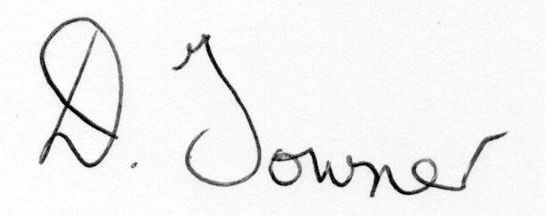
Doug Towner (President LCME)

NSW with.

